Portfolio Site



|  |  |
| --- | --- |
| Page | Content |
| 2 | Table on Contents |
| 3 | Description |
| 3 | Nav Bar |
| 4 | Colours |
| 5 | Typography |
| 6 | Wireframe Section |
| 7 | Branding |

**Description**

My site is an adaptive HTML5 web page designed to easily transition between regular and mobile browsers. It consists of 5 pages and minimal JavaScript.

**Nav Bar**



The Nav Bar appears as shown above. The active page will appear the same colour as the border at the bottom of the header.



On mouse-over the text changes to a dark blue. 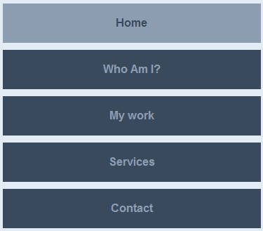

Above is the mobile version of the Nav Bar

**Colours**

(http://colorschemedesigner.com/#3C11DddhNwVwV)

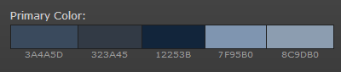

**Typography**

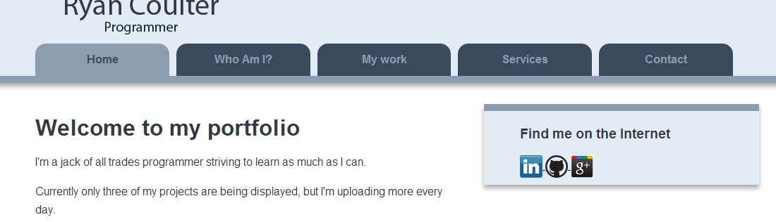

|  |  |  |  |
| --- | --- | --- | --- |
| **#** | **Font** | **Size** | **Colour** |
| 1 | Myriad Pro | 20pt | # 313a45 |
| 2 | Arial | 16px | #12253B |
| 3 | Arial | 2em | #313A45 |
| 4 | Arial | 16px | #313A45 |

**Wire Frame**

Nav Bar Logo Info Panel

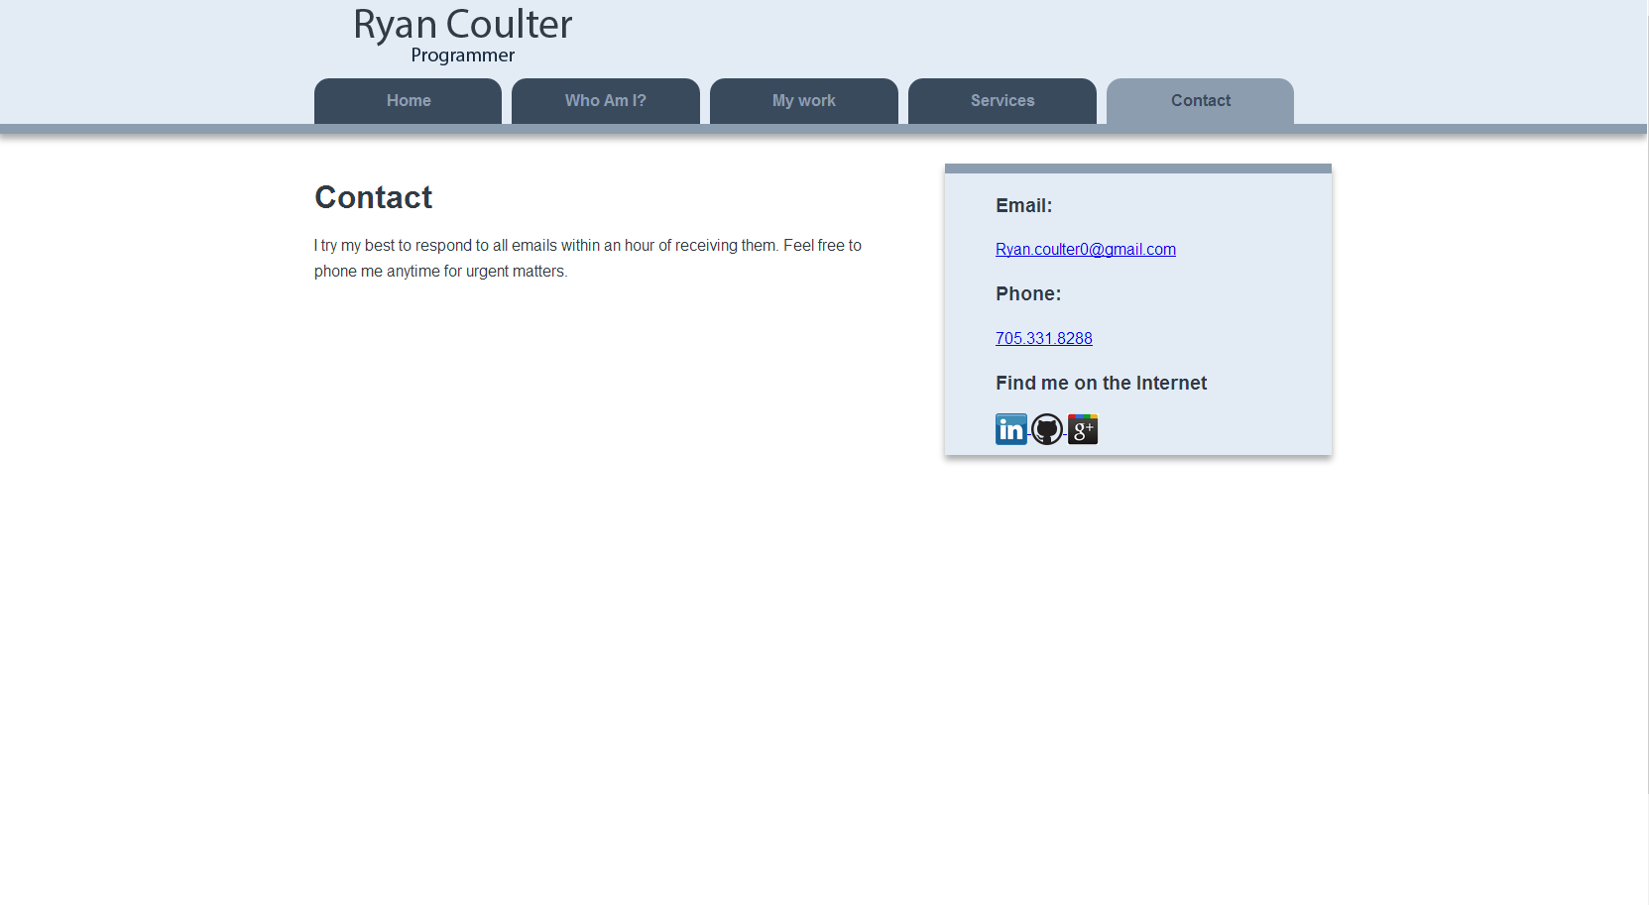

Footer

Articles

**Branding**